**COMPUTER SCIENCE DEPARTMENT**

Computer Organization and Assembly Language

**Lab Task # 05**

**Last date of Submission: 24th March 2024**

# Submitted To: Sir Ahmed Saleem Khattak

**Student Name: UBAID-BIN-WARIS**

# Reg. Number: 2212416

# 

**Code no.1**

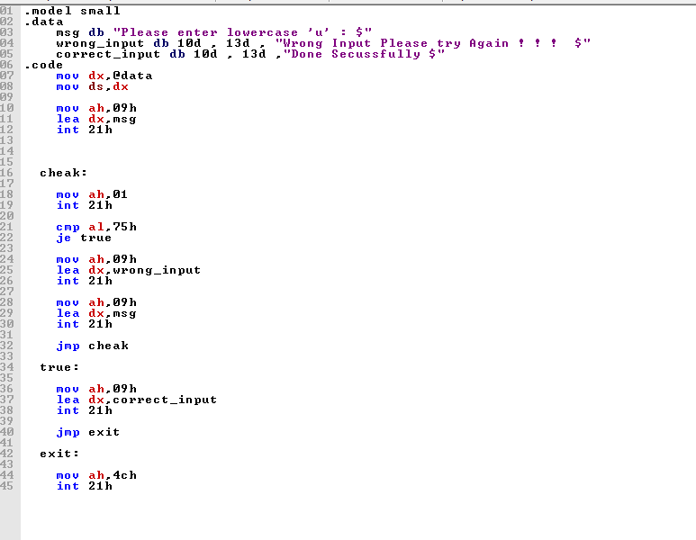

**Output**

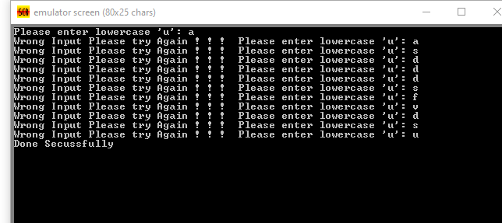

**Code no.2**

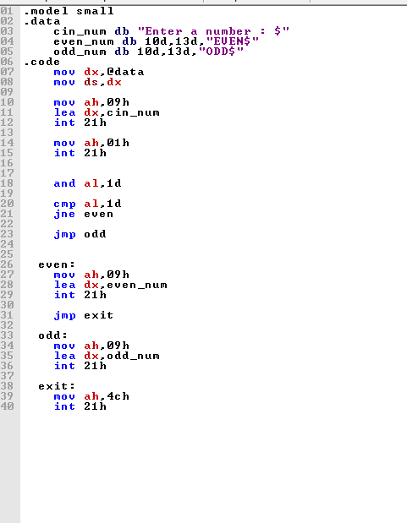

**Output**

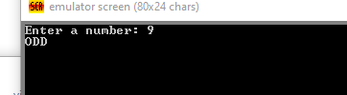

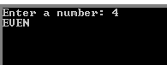

**Code no.3**

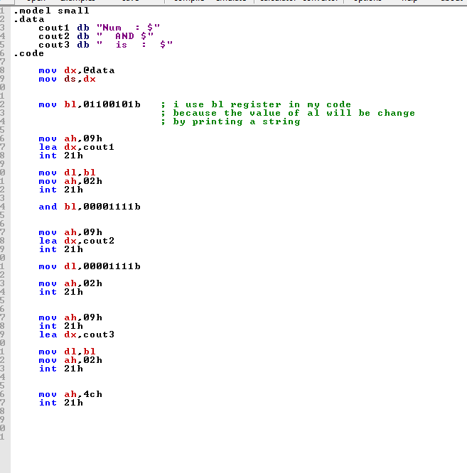

**Output**

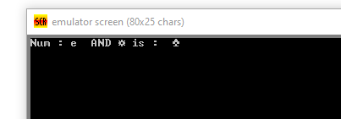

**Code no.4**

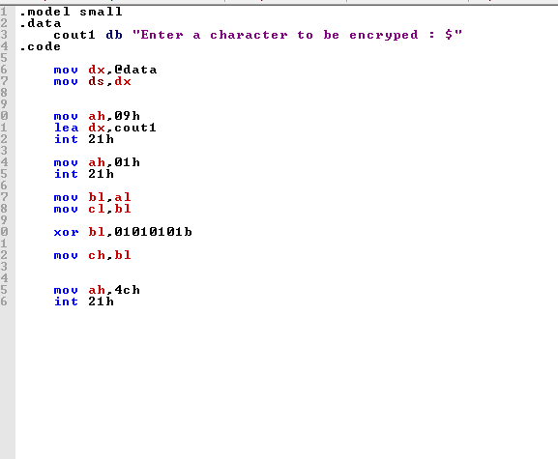

**Output**





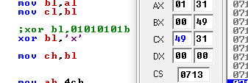

**Code no.5**

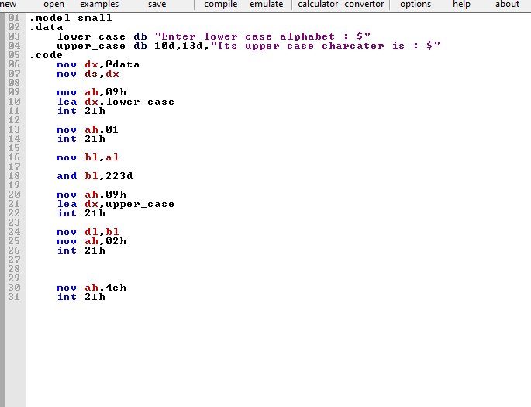

**Output**



